# STEP 1 - Complete the e-Landlord Registration Form

Please complete the following form, print out, sign, and include in your registration email.

e-Landlord Registration Form/ Formulaire d’inscription e-Proprio

|  |  |
| --- | --- |
| **General E-Landlord Information/ Information Générale e-Proprio** | |
| Property Owner/ Propriétaire: |  |
| Company or Property Management  Name/ Nom de l’entreprise gestionnaire de l’entreprise : |  |
| Are you set up for Electronic Funds Transfer (EFT)? If so, what is your EFT number? /  Est-ce que vous êtes enregistré pour Transfert électronique de fonds (TEF)? Si oui, quel est votre numéro de compte? |  |
| **E-Landlord Contact Information/ Information du Contact e-Proprio** | |
| Contact Person/ Personne Contacte: |  |
| Email Address/ Adresse Courriel: |  |
| Telephone Contact Info: Office/ Bureau:  Numéros de telephone |  |
| Fax/ Télécopieur: |  |
| Mailing Address/ Street Address, Unit/ Adresse Postale: Rue, Unité: |  |
| City, Province/ Ville, Province: |  |
| Postal Code/ Code Postal: |  |
| Number of Units/ Nombre d’unités:  *(If available/ Si disponible)* |  |
| Unit Location(s) (Street Address, Unit, City) / Lieu des unités (Rue, Unité, Ville)  *If you need more space, please attach another page/*  *Si vous avez besoin de plus d’espace, vous pouvez attacher une autre page.* |  |
| **OFFICE USE ONLY/ USAGE INTERNE SEULEMENT** | |
| e-Landlord Account Name/ Nom du compte e-Proprio |  |
| e-Landlord Number/ Numéro e-Proprio: |  |
| e-Landlord Effective Date/ Entrée en vigueur: |  |
| EFT Landlord/ e-Proprio TEF: |  |
| CPT Landlord/ e-Proprio TPC: |  |
| Consent To Use E-mail Address/ Consentement à l'utilisation de l’Adresse Courriel: |  |
| **I hereby grant the Residential Tenancies Tribunal the right to communicate with the landlord named above using this email address on matters pertaining to *the Residential Tenancies Act* of New Brunswick. For all email requests for a release, you agree to respond in 5 calendar days. Your failure to do so will result in the security deposit being released to the tenant**  **Sujet à l’application de la *Loi sur la location des locaux d’habitation* du Nouveau-Brunswick, par la présente je donne permission au Tribunal sur la location de locaux d’habitation de communiquer avec le propriétaire identifié par moyen de l’adresse courriel indique. Pour toutes les demandes envoyées par courriel, vous vous engagez à y répondre à l’intérieur de 5 jours suivant. Votre incapacité à le faire se traduira par la remise du dépôt de garantie au locataire.** | |
| **Contact Name /Personne contacte** | **Signature/ signature Date/date** |
|  |  |

# STEP 2 Register for your secure access

In order to use the e-Landlord portal, you must create what is known as an IAM Client Account (i.e. a “company” account), and also designate an IAM Client Administrator (i.e. someone who will manage your “company” account).

## STEP 2.1 Completing your IAM Client Account Registration

This step is only required if you do not already have an IAM Client Account. If you do, please proceed to STEP 2.2.

* Complete the “Client Authentication – Part 1 – Client Registration” form available [<<here>>](https://www.pxw1.snb.ca/snb7001/b/1000/CSS-FOL-SNB-SN-0020b.pdf)
* Print out the completed form and sign it where required

## STEP 2.2 Completing your IAM Client Administrator Registration

This step is only required if you have not already designated an IAM Client Administrator for your IAM Client Account. An IAM Client Administrator is someone that you nominate who can manage your IAM Client Account, including granting access to IAM users to your IAM Client Account.

* Complete the “Client Authentication – Part 3 – Client Administrator Registration” form available [<<here>>](https://www.pxw1.snb.ca/snb7001/b/1000/CSS-FOL-SNB-SN-0022b.pdf)
* The user who will be your IAM Client Administrator must start by creating an IAM account on the SNB website. If this person already has an IAM account, please go to Step 3.
* Access the link: [www.snb.ca/iam](http://www.snb.ca/iam). You will receive the following screen: 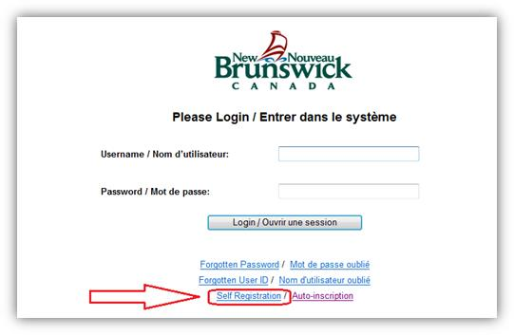
* Click the “Self-Registration” link and complete the process to create an IAM account. Please make note of your IAM User ID and Account Number as this will be required in a later step.
* Fill out the “Client Authentication – Part 3 – Client Administrator Registration” form:
  + Within the “Client Administrator Details” section, enter the user’s information who will be your IAM Client Administrator. For the “USER ID OR ACCOUNT NUMBER” field, please enter the information you noted in Step 2 above (or that the user had already from an already existing registration).

# STEP 3 – Register for EFT

Please complete the form below to take advantage of the “Electronic Funds Transfer – EFT” module; this step is only required if you have not already registered for an EFT account.

To register for EFT:

* Complete the “Financial Officer Registration and (PAD) Pre-Authorized Debit Form” available [<<here>>](https://www.pxw1.snb.ca/snb7001/b/1000/CSS-FOL-SNB-SN-0021b.pdf)
* Print out the completed form and sign it where required

# SUMMARY

* A completed and signed “e-Landlord Registration Form”
* Step 2.1, a completed and signed “Client Authentication – Part 1 – Client Registration”
* Step 2.2, a completed “Client Authentication – Part 3 – Client Administrator Registration” with either IAM user ID or IAM account number provided on form.
* Step 3, a completed and signed “Financial Officer Registration and (PAD) Pre-Authorized Debit Form”, along with a cheque specimen or a voided cheque.